Ideation Phase Brainstorm & Idea Generation

Step-1: Team Gathering, Collaboration and Select the Problem Statement

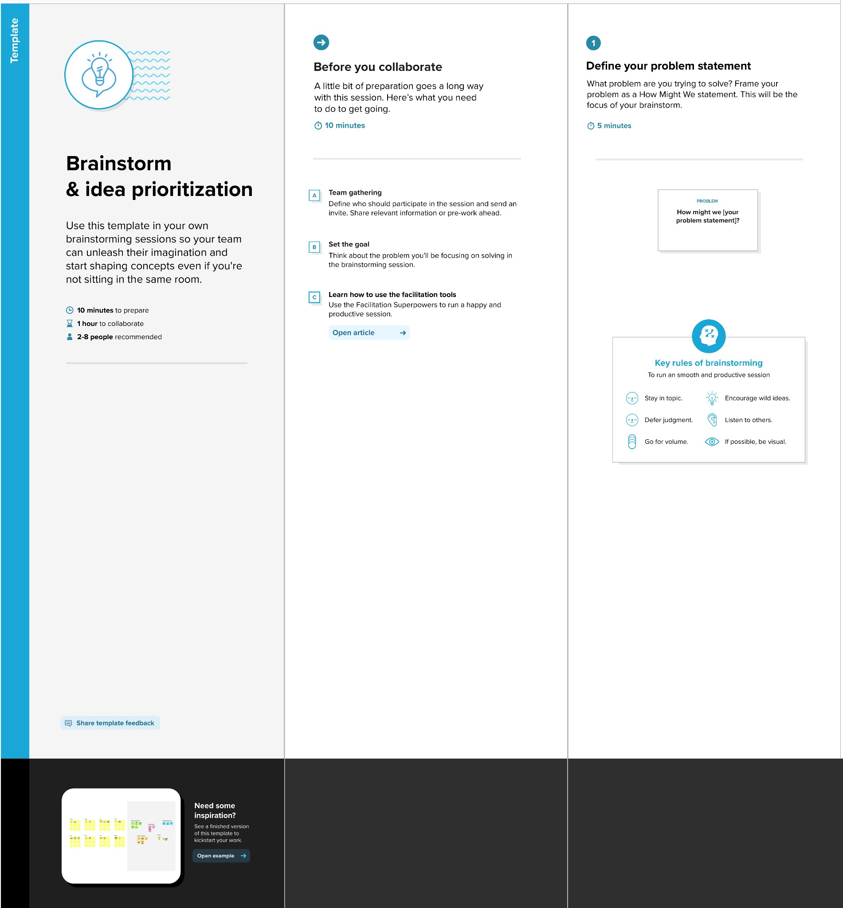

**Step-2: Brainstorm, Idea Listing and Grouping**

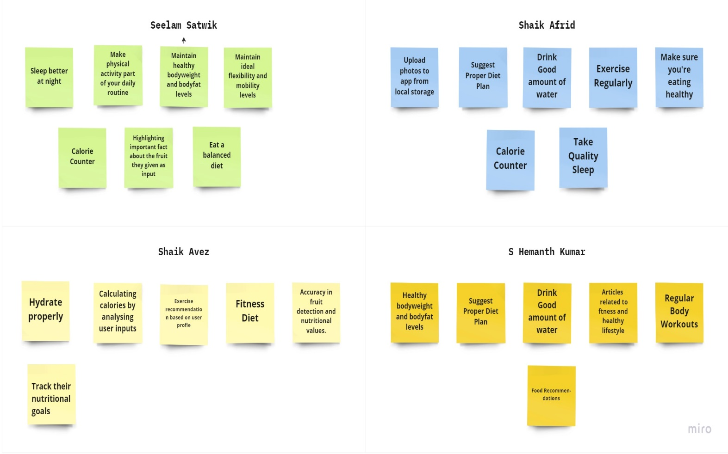

Step-3: Group Ideas

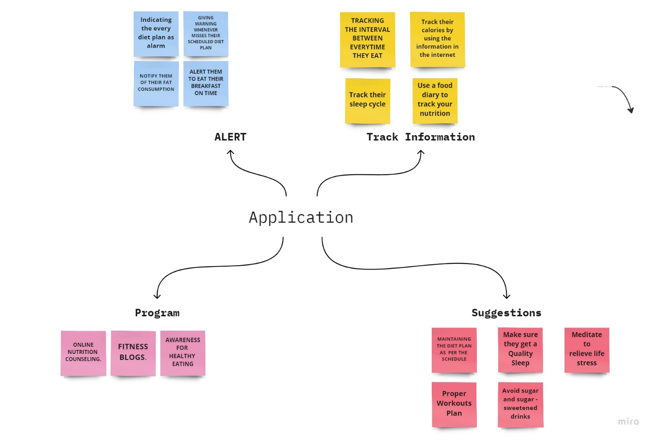

Step-4: Idea Prioritization

